

**Tunku Abdul Rahman University College**

**BACS2173**

**Graphics Programming**

**Jaegers Prototype**

|  |  |  |
| --- | --- | --- |
| **Programme** | **:** | RSF2 |
| **Tutorial Group** | **:** | 1 |
| **Date Submitted to Tutor** | **:** | 14/4/2021 |

**Team Members:**

|  |  |  |  |  |
| --- | --- | --- | --- | --- |
| **No** | **Student Name** | **Student ID** | **Contribution (%)** | **Signature** |
| **1.** | Lee Kai Yang | 19WMR11671 | 50 |  |
| **2.** | Tang Xiao Zu | 19WMR11402 | 50 |  |
| **Total** | | | **100** | **-** |

|  |  |  |
| --- | --- | --- |
| No. | Team Member | Task(s) Allocated |
| 1. | Lee Kai Yang | * Refactor function calls into separate classes * Programmed the jaeger’s thruster and some other abilities * Programmed some of the jaeger’s body parts. |
| 2. | Tang Xiao Zu | * Draw the initial sketch of the jaeger, sketch the overview of jaeger’s features. * Write the report and user manual * Programmed some of the jaeger’s body parts |

**Declaration**

We confirm that we have read and shall comply with all the terms and conditions of TAR University College’s plagiarism policy.

We declare that this assignment is free from all forms of plagiarism and for all intents and purposes is my own properly derived work.

|  |  |  |  |
| --- | --- | --- | --- |
| Signature | : |  |  |
| Name | : | Lee Kai Yang | Tang Xiao Zu |
| Date | : | 14/4/2021 | 14/4/2021 |

BACS2173 Computer Graphic Programming Assignment 2021

|  |  |  |  |  |  |
| --- | --- | --- | --- | --- | --- |
| Criteria | Marks | Excellent | Rating Very Poor to Excellent | Very Poor | Comments |
| Completeness | 10 | Final model is fully work and less bugs. Overall is well prepared. | 10 9 8 7 6 5 4 3 2 1   |  |  |  |  |  |  |  |  |  |  | | --- | --- | --- | --- | --- | --- | --- | --- | --- | --- | |  |  |  |  |  |  |  |  |  |  | | Final model is incomplete and lots of bugs. |  |
| Techniques Applied | 10 | Complete techniques applied include texture and lighting. | 10 9 8 7 6 5 4 3 2 1   |  |  |  |  |  |  |  |  |  |  | | --- | --- | --- | --- | --- | --- | --- | --- | --- | --- | |  |  |  |  |  |  |  |  |  |  | | No technique applied. |  |
| Interactive Features | 10 | Model is very flexible. All parts are moving freely. | 10 9 8 7 6 5 4 3 2 1   |  |  |  |  |  |  |  |  |  |  | | --- | --- | --- | --- | --- | --- | --- | --- | --- | --- | |  |  |  |  |  |  |  |  |  |  | | Model has no or limited interactive feature. |  |
| Viewport/ Projection | 10 | Complete viewport with orthographic and perspective projections. Fully transformations for both views. | 10 9 8 7 6 5 4 3 2 1   |  |  |  |  |  |  |  |  |  |  | | --- | --- | --- | --- | --- | --- | --- | --- | --- | --- | |  |  |  |  |  |  |  |  |  |  | | Only one default projection with no transformations. |  |
| Animations | 10 | Good animation and complicated movement. | 10 9 8 7 6 5 4 3 2 1   |  |  |  |  |  |  |  |  |  |  | | --- | --- | --- | --- | --- | --- | --- | --- | --- | --- | |  |  |  |  |  |  |  |  |  |  | | No animation or only one animation with very simple movement. |  |
| Model Design | 10 | Complicated design with variety of geometric primitives. | 10 9 8 7 6 5 4 3 2 1   |  |  |  |  |  |  |  |  |  |  | | --- | --- | --- | --- | --- | --- | --- | --- | --- | --- | |  |  |  |  |  |  |  |  |  |  | | Simple design with only using quadric. |  |
| Complexity/ Primitive Count | 10 | Complex model with more than 500 polygon count. | 10 9 8 7 6 5 4 3 2 1   |  |  |  |  |  |  |  |  |  |  | | --- | --- | --- | --- | --- | --- | --- | --- | --- | --- | |  |  |  |  |  |  |  |  |  |  | | Simple model with less than 200 polygon count. |  |
| Specific Features | 10 | Model has a lot of  specific features/customizations and weapons. | 10 9 8 7 6 5 4 3 2 1   |  |  |  |  |  |  |  |  |  |  | | --- | --- | --- | --- | --- | --- | --- | --- | --- | --- | |  |  |  |  |  |  |  |  |  |  | | Model has no specific features /customization and without weapon. |  |
| Documentation | 10 | Complete document with  detail information | 10 9 8 7 6 5 4 3 2 1   |  |  |  |  |  |  |  |  |  |  | | --- | --- | --- | --- | --- | --- | --- | --- | --- | --- | |  |  |  |  |  |  |  |  |  |  | | Incomplete documentation. |  |
|  | | | | Total [90] |  |

BACS2173 Computer Graphic Programming Assignment 2021

|  |  |  |  |  |  |  |  |  |  |  |  |  |  |  |  |
| --- | --- | --- | --- | --- | --- | --- | --- | --- | --- | --- | --- | --- | --- | --- | --- |
| Personal appraisal / Presentation | 10 | Detail personal appraisal and good presentation  skill which able to demonstrate the model clearly with complete explanation. | 10 9 8 7 6 5 4 3 2 1   |  |  |  |  |  |  |  |  |  |  | | --- | --- | --- | --- | --- | --- | --- | --- | --- | --- | |  |  |  |  |  |  |  |  |  |  | | Simple personal appraisal and poor presentation skill which unable to demonstrate the model clearly. |  |
|  |  |  |  | Total [100] |  |

# **Content**

**Content** **6**

**Introduction** **7**

**System Specification** **7**

**Design Concept** **7**

**Polygon Counts** **10**

**User Manual** **11**

# **Introduction**

The jaeger we designed as a 3-D model is able to perform a number of interactive features, customizations features and animations. This jaeger is named “Iron-Man” and it is able to perform basic movements such as walking and jumping, it is also able to rotate its head, arm, body, hand, wrist, finger and leg. Furthermore, Iron-Man has two abilities which is launching an energy ball from 2 hands and shoots it out, the second ability is combining 2 energy balls into 1 energy ball and shoots it. Moreover, Iron-Man is able to switch its colour from red to gold. Last but not least, we added some texture and different color tones to make it look more realistic.

# **System Specification**

The jaeger is developed using Visual Studio 2019 (Windows edition) along with LucidChart (a web-based sketching tool) to help sketch an overview of the model's interactivity and functionalities. We used the OpenGL API (Application Programming Interface) provided by the Windows SDK (Software Development Kit) as our graphics library, it helps us talk to the GPU (Graphical Processing Unit) and provide a set of functions to create the model. The primitives of the model include GL and GLU primitives. Other than that, the libraries we used in this project are <Windows.h>, <gl/GL.h>, <gl/GLU.h> and <math.h>. Moreover, some of the textures that are being used in this project are converted into BMP files through Paint.

# **Design Concept**

For the design of this jaeger, most of the ideas came from one of our favourite movies which is The Avengers. In The Avengers, we try to design our jaeger to look like Iron-Man. In order to do this, we have referred a lot of sources from the Internet in order to build our jaeger. For the abilities, this idea came from an anime which is called “Dragon Ball”, the abilities we design is similar to the ability used by the main character “Goku” and is called “Kamekameha”. The jaeger we created is like a mixed hero which is very powerful and would be able to protect humans from monsters.

|  |  |
| --- | --- |
| *Figure 1: Purple Goku* | *Figure 2: Red Goku* |
| *Figure 3: Iron Man* | |

We combine both the body of “Iron-Man” and the abilities of “Goku” and the combination of the whole jaeger is as the sketch below:

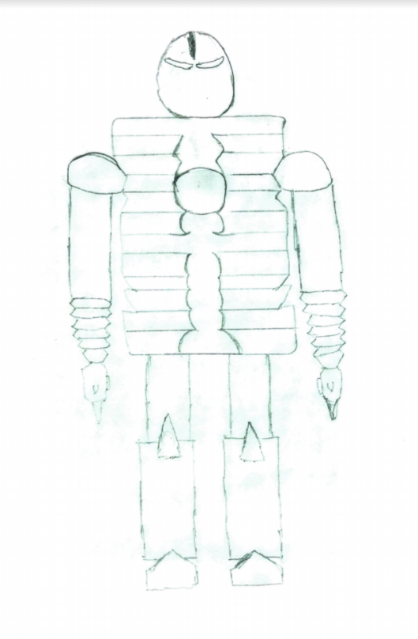

*Figure 4: Sketch of jaeger “Iron-Man”*

# **Polygon Counts**

|  |  |
| --- | --- |
| Geometric Primitive | Counts |
| Sphere | 11 |
| Polygon | 36 |
| Cylinder | 26 |
| Triangle | 74 |
| Quad | 236 |
| Disk | 128 |

# 

# **User Manual**

|  |  |  |  |
| --- | --- | --- | --- |
| **Key** | **Remark** | **Key** | **Remark** |
| W | Walk Front | 1 | Turn Head Down |
| S | Walk Back | 2 | Turn Head Up |
| A | Open Whole Arm | 3 | Turn Head Left |
| D | Close Whole Arm | 4 | Turn Head Right |
| TAB | Reset Move | 6 | Turn Upper Body Left |
| SPACE | Jump | 7 | Turn Upper Body Right |
| R | 1st Ability | 8 | Close Finger |
| T | 2nd Ability | 9 | Open Finger |
| M | Turn Whole Body To Right | F1 | Move Right Leg Up |
| N | Turn Whole Body To Left | F2 | Move Right Leg Down |
| X | Move Elbow Up | F3 | Move Left Leg Up |
| Z | Move Elbow Down | F4 | Move Left Leg Down |
| V | Move Elbow In | F5 | Move Right Knee Front |
| B | Move Elbow Out | F6 | Move Right Knee Back |
| K | Move Elbow 45° Out | F7 | Move Left Knee Front |
| L | Move Elbow 45° In | F8 | Move Left Knee Back |
| U | Move Upper Hand Up | BACKSPACE | Colour Change |
| I | Move Upper Hand Down | HOME | Enable Thruster |
| Q | Move Palm Out | END | Disable Thruster |
| E | Move Palm In | ESC | Exit Program |
| ARROW UP | Fly upwards (must enable thruster) | ARROW LEFT | Fly left (must enable thruster) |
| ARROW DOWN | Fly downwards (must enable thruster) | ARROW RIGHT | Fly right (must enable thruster) |
| P | Play/Pause BGM |  |  |